Q) HOW TO CREATE STORAGE ACCOUNT,CONTAINER AND UPLOAD/DELETE OBJECTS STEPS:

1) OPEN MICROSOFT AZURE PORTAL AND CLICK ON STORAGE ACCOUNT

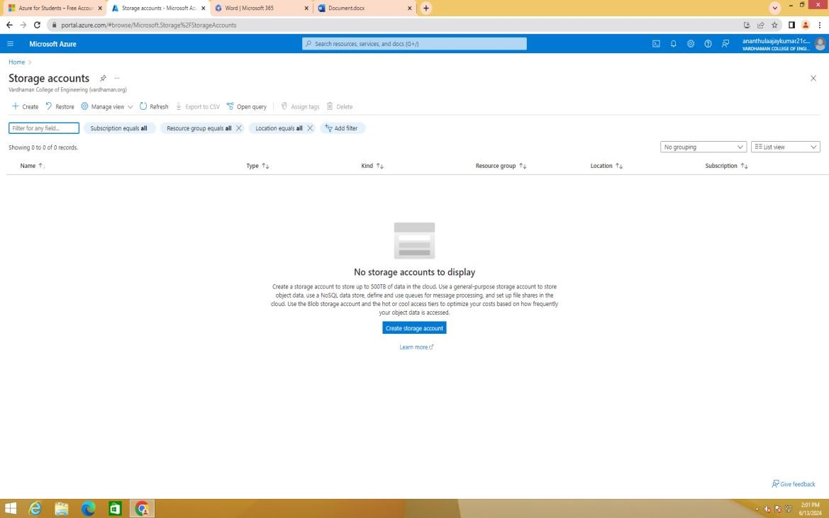

2)CLICK ON CREATE,SELECTS LRS/GRS IN REDUNDANCY

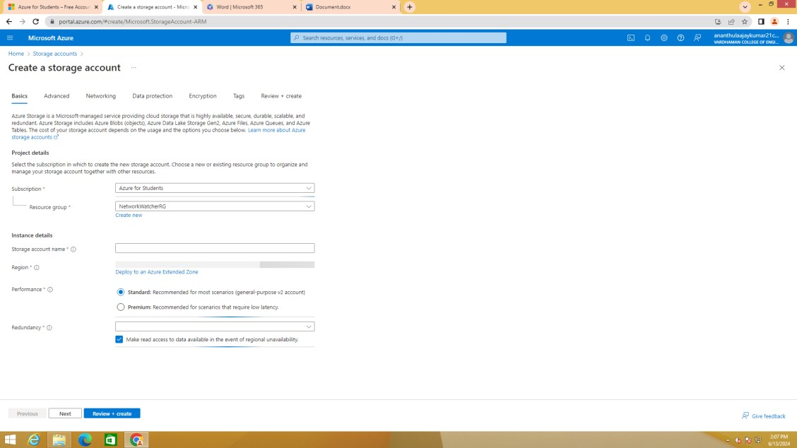

3)CLICK ON NEXT,TICK “ALLOW ENABLING ANONYMOUS ACCESS ON INDIVIDUAL

CONTAINERS

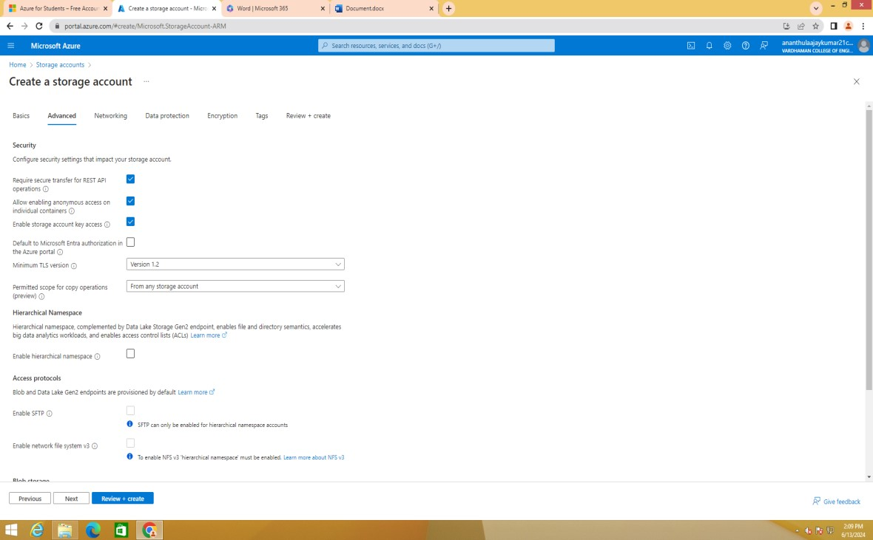

4)CLICK ON REVIEW+CREATE AND CLICK ON CREATE

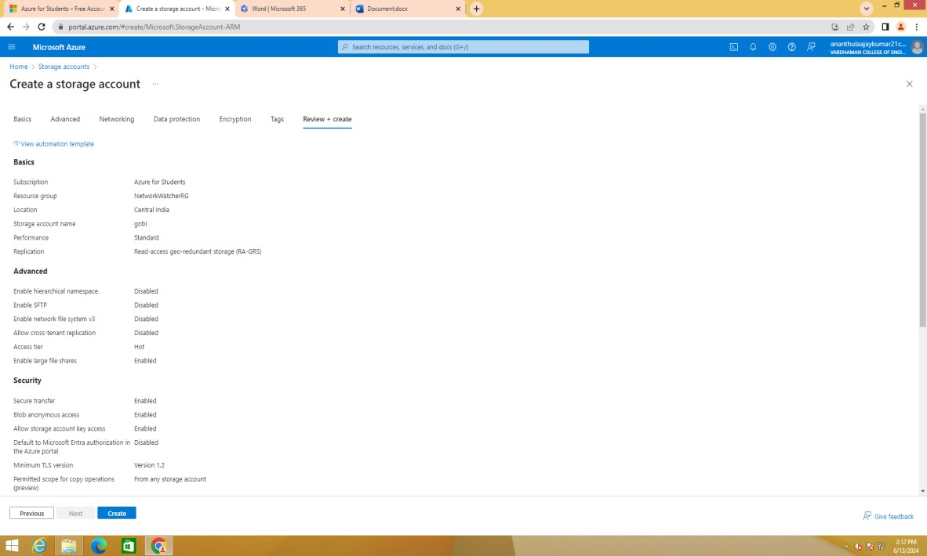

5)OPEN STORAGE ACCOUNT WHICH YOU HAVE CREATED

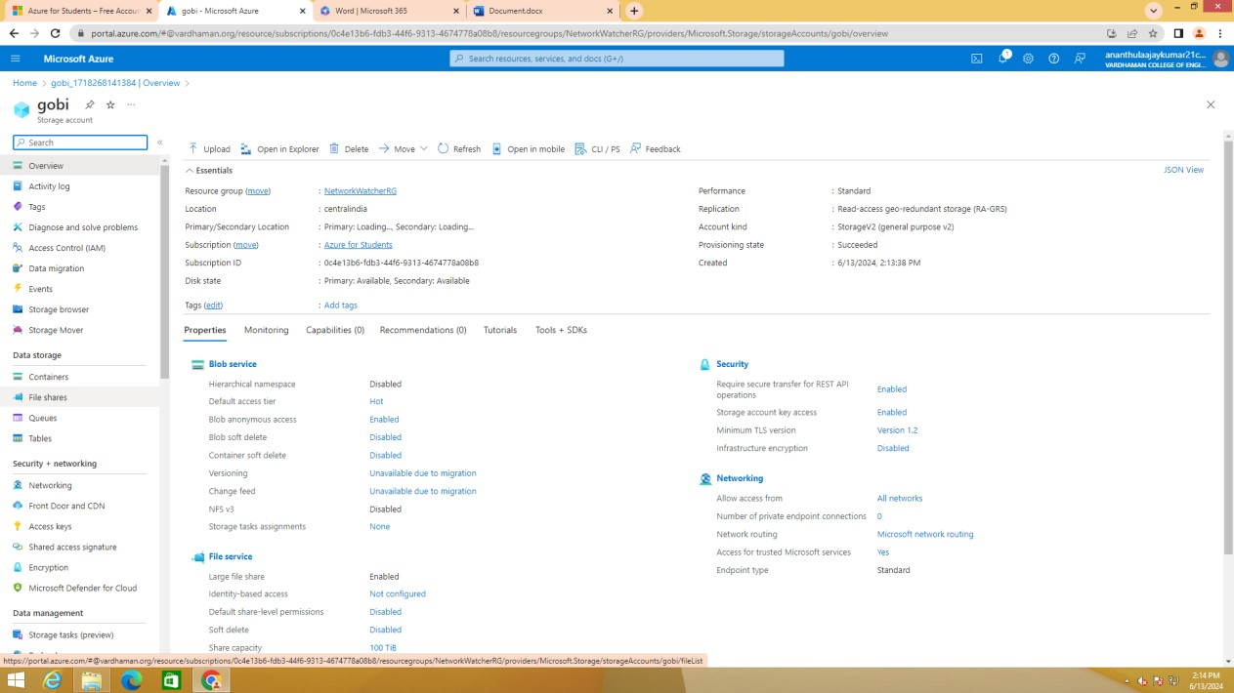

6) CLICK ON DATA STORAGE AND SELECT CONTAINER

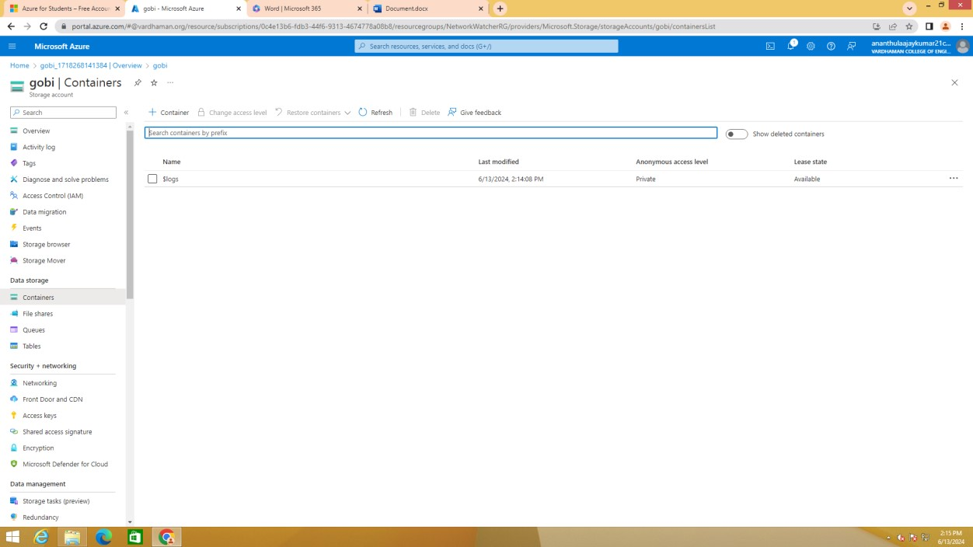

# 7)GIVE A NAME AND SELECT “BLOB” IN ANONYMOUS ACCESS LEVEL AND CLICK ON CRATE

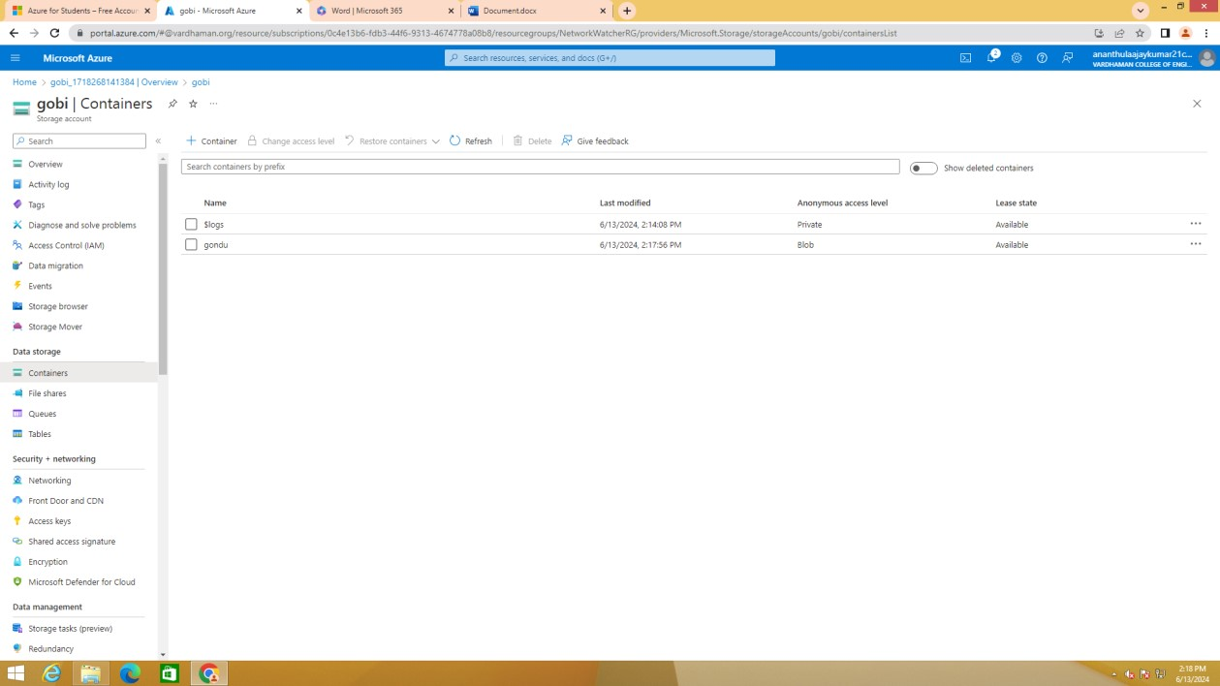

8)CLICK ON UPLOAD

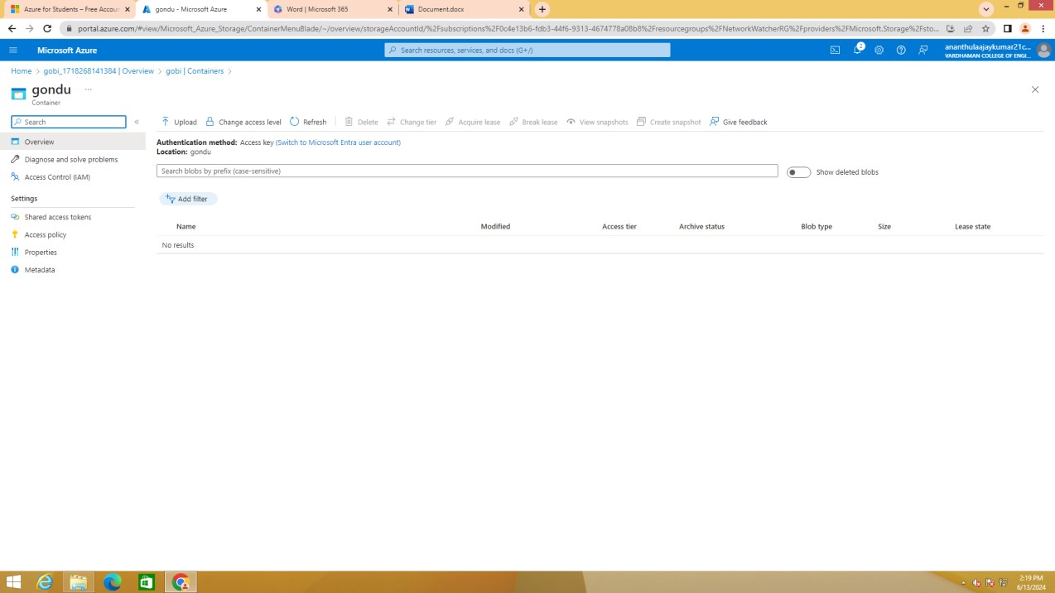

# 9)CLICK ON “BROWSE FOR FILE”

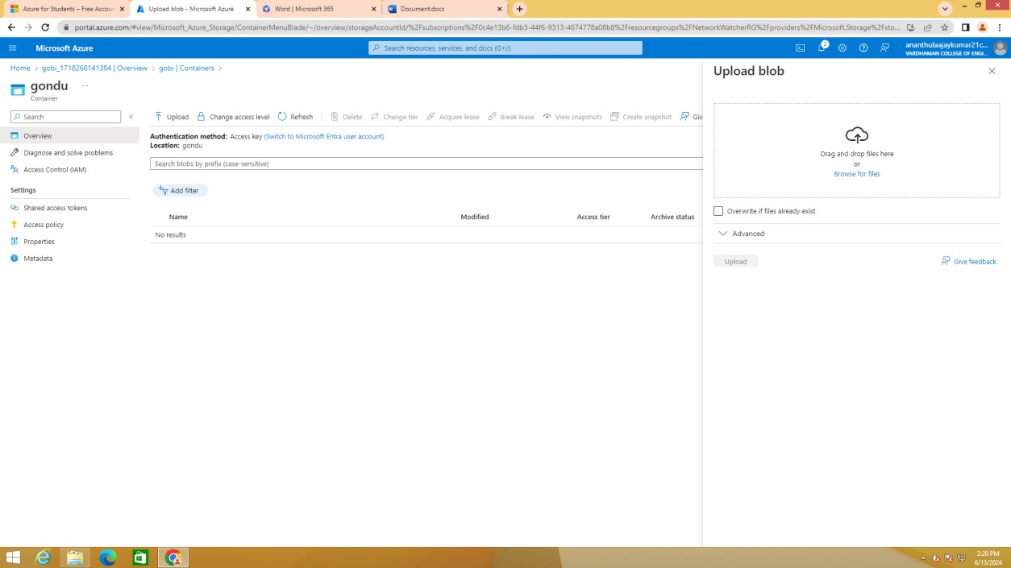

10)UPLOAD ANY FILE/IMAGE/AUDIO/VIDEO

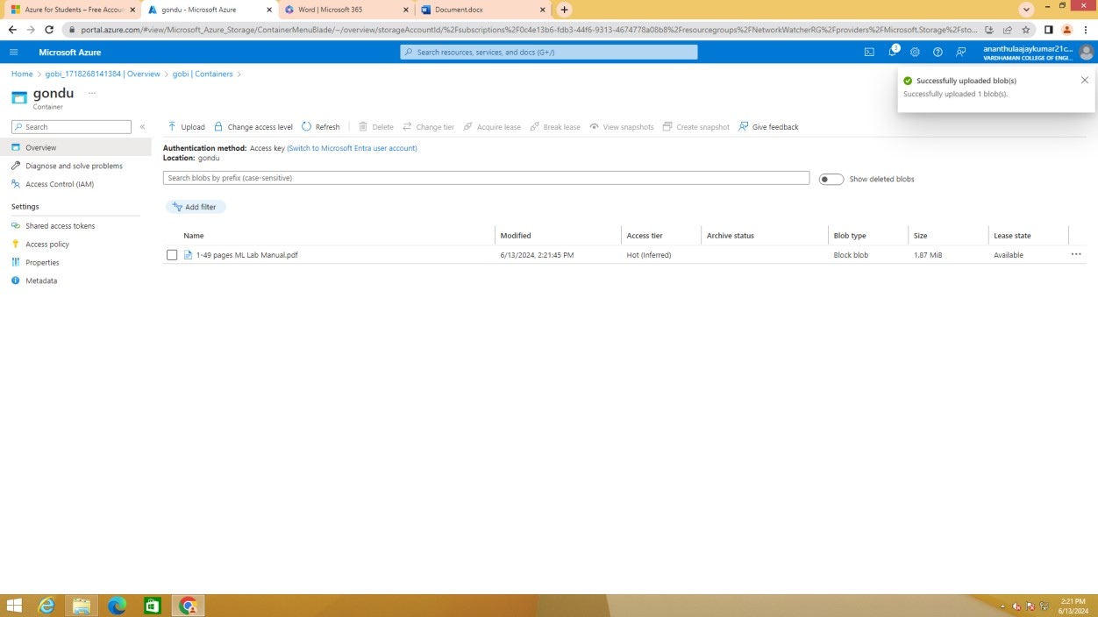

11)CLICK ON THE FILE WHICH YOU HAVE UPLOADED

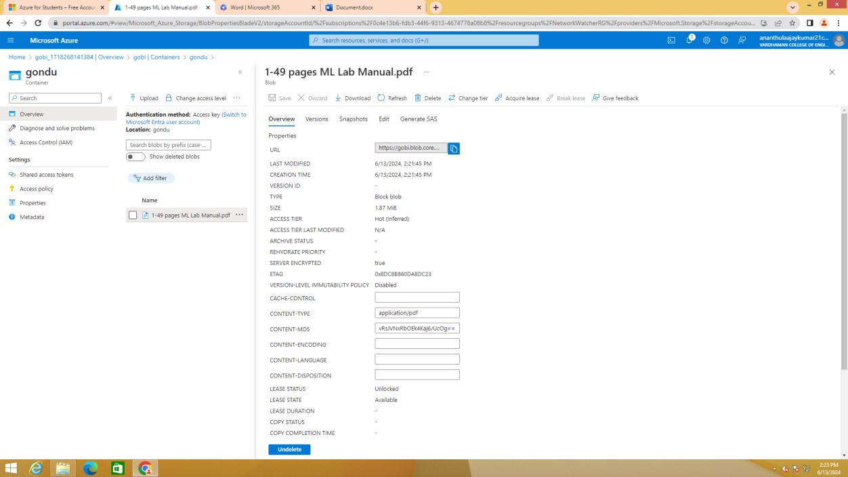

12)COPY THE URL

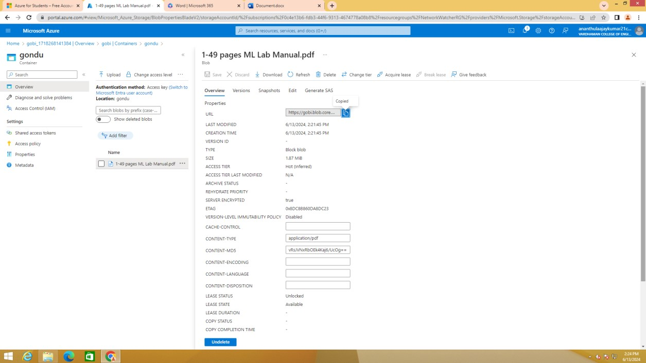

13)PASTE THE URL IN ANY BROWSER

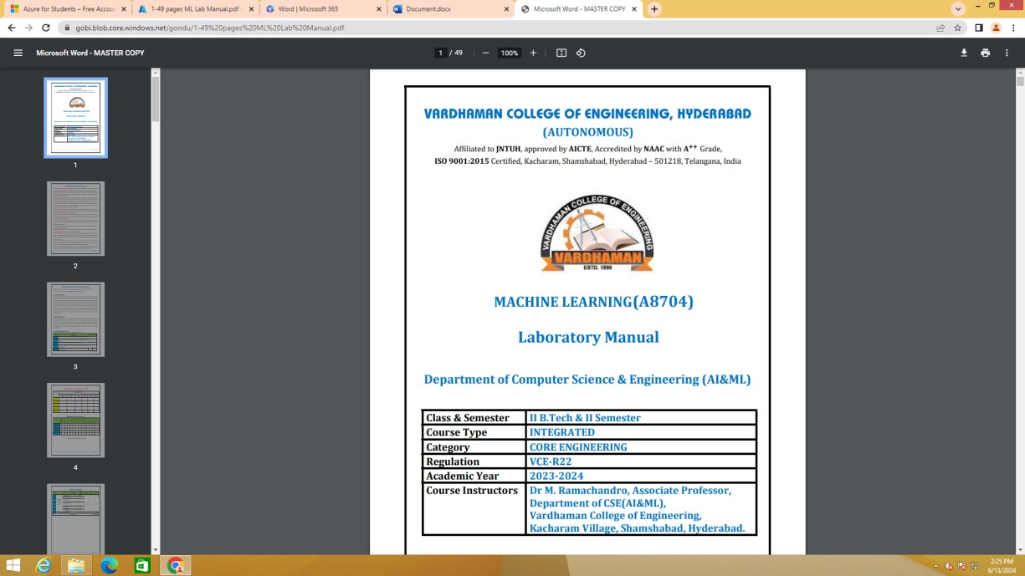

14)TO CHANGE THE ACCESS LEVEL,CLICK ON CHANGE ACCESS LEVEL

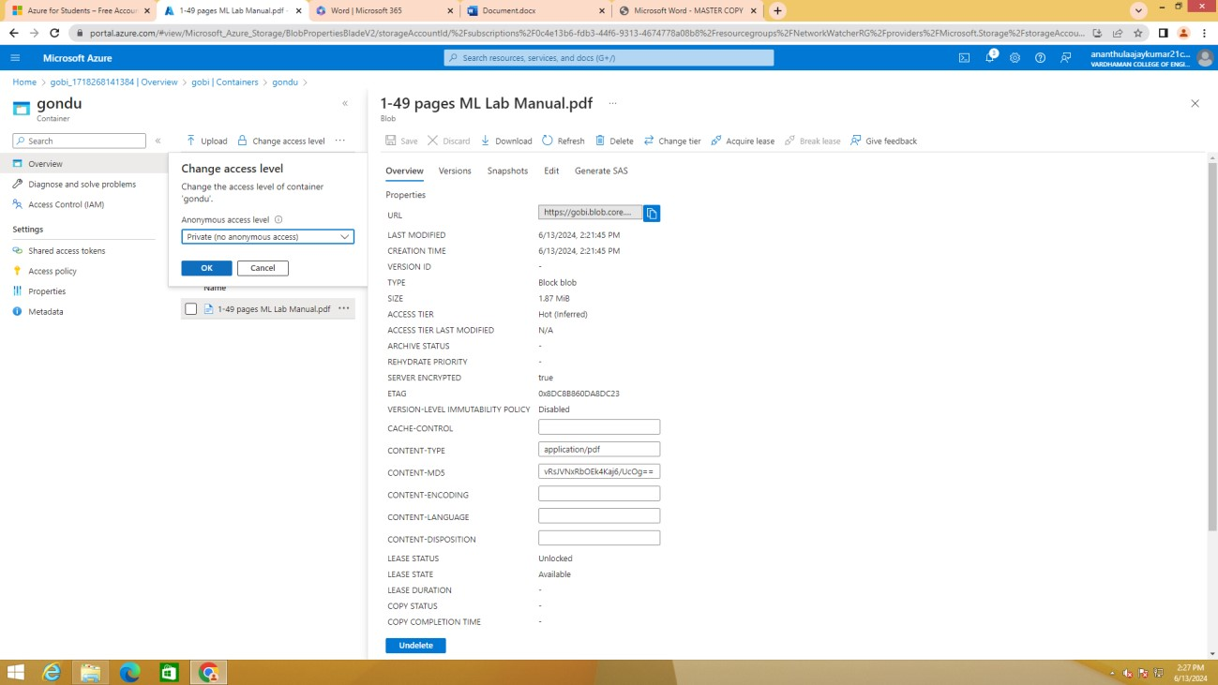

15)SELECT ANY ANONYMOUS ACCESS LEVEL AND CLICK ON OK



16)AGAIN COPY THE URL OF THE FILE WHICH YOU HAVE UPLOADED PREVIOUSLY AND PASTE IT ANY BROWSER

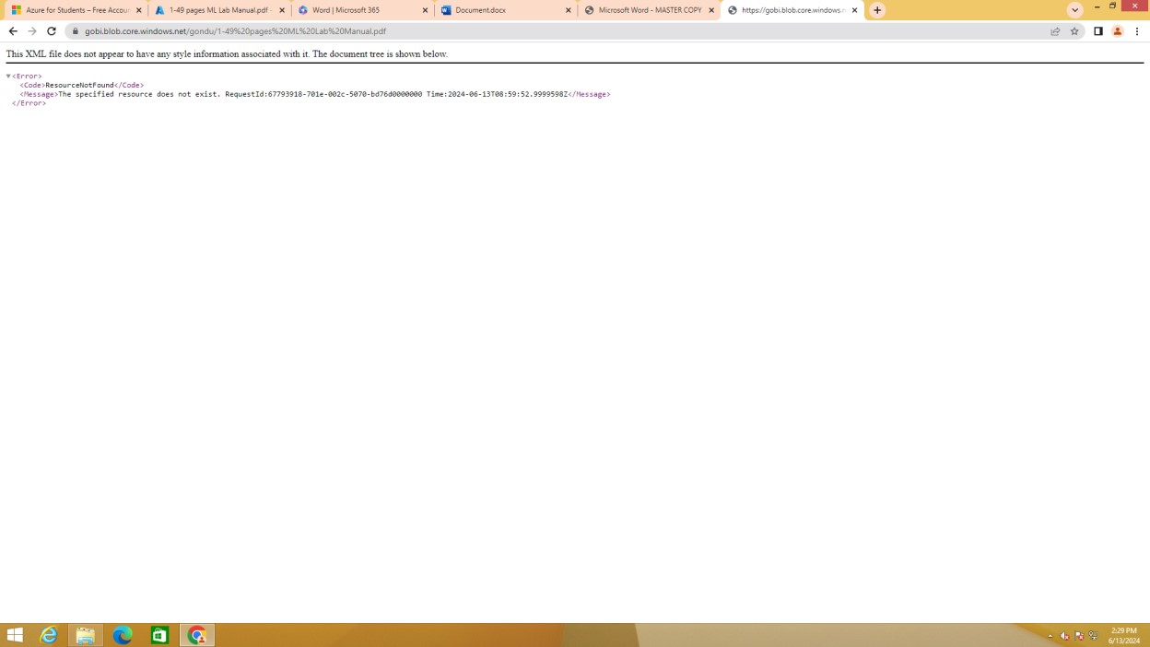

17)TO DELETE A BLOB,SELECT THE BLOB AND CLICK OB DELETE 18)TO VIEW THE DELETED BLOBS,CLICK ON “ SHOW ON DELETED BLOBS“

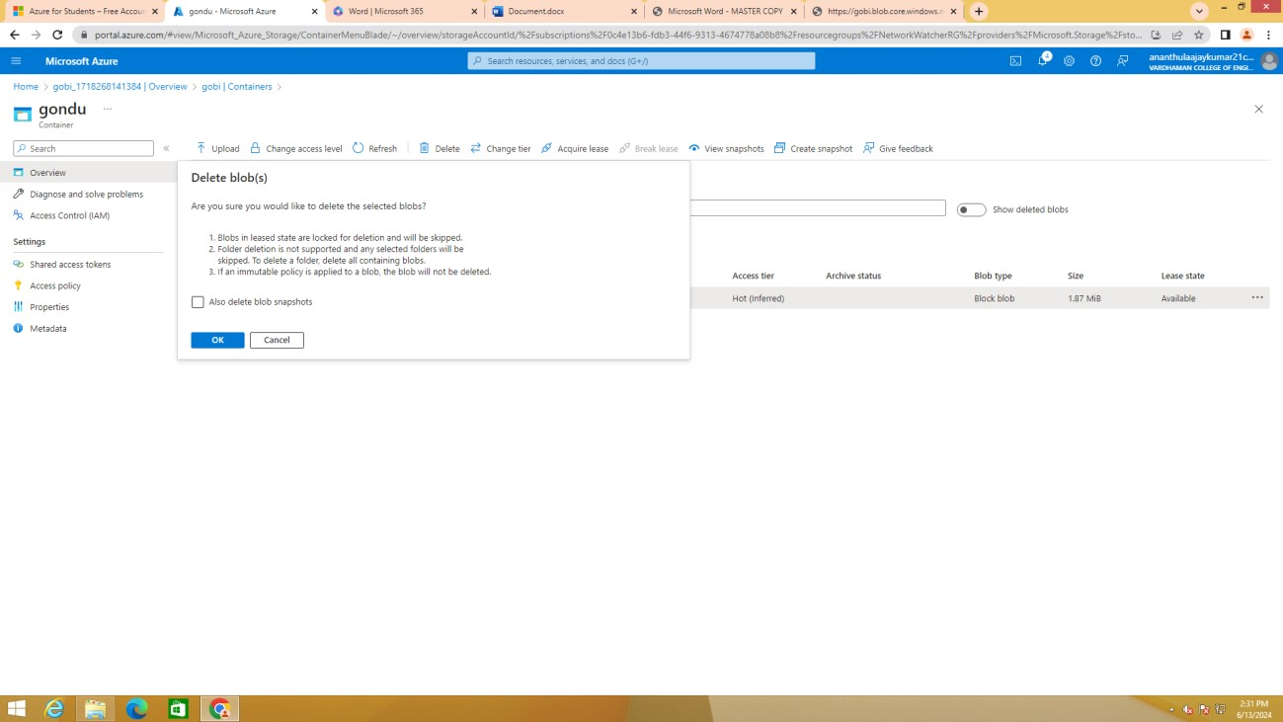

19)TO UNDO DELETED BLOB :

SELECT THE BLOB CLICK ON MORE AND CLICK ON UNDELETE

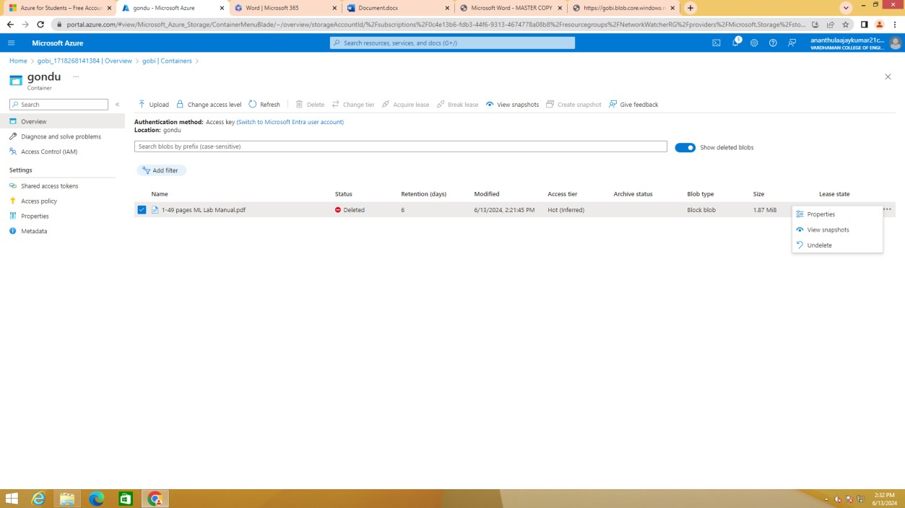

https://github.com/8639919165/ccv